Hi Sunny –

For this next project I’m hoping to be able to scrape the information down from the following website: <https://wsb.gold/public/dashboard/e65fcfcb-70a4-4d86-b7fb-888057c67881#refresh=300>

There are many widgets on the page and some even have multiple pages to them. The specific one I’m most interested in is below:

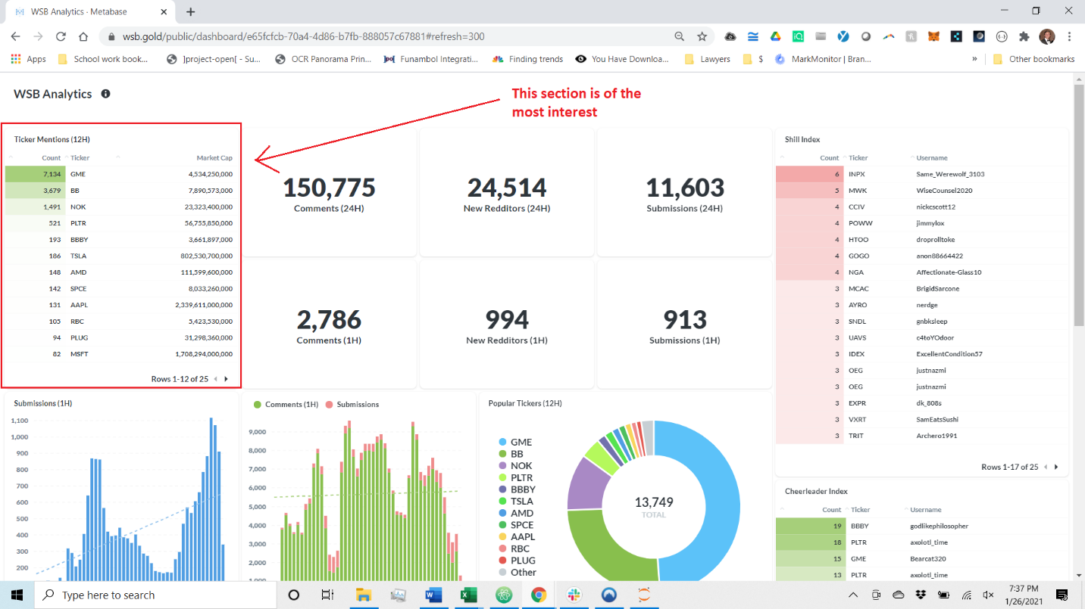

If we can only pull the info from this one, I’d be very happy – the other stuff can be skipped if there’s any real challenge posed to getting the info.

I’m not sure, but it may require a creative workaround to scrape the information. Perhaps even taking a snapshot of the website itself and then using OCR to translate the image into text: <https://towardsdatascience.com/how-to-extract-text-from-images-with-python-db9b87fe432b>